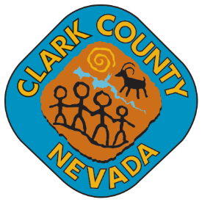**Colorado River Heritage Greenway**

**Park and Trail Council**

**Laughlin Regional Government Center**

**101 Civic Way**

**Laughlin, Nevada 89029**

January 14, 2025

10:30 a.m.

|  |
| --- |
| Board Members: Deborah Murray – Chair Fred Doten - Vice Chair  Victoria Conely Kathleen Hoss Renee Yepez    Secretary: Kathleen Hoss    Town Liaison: Mark Moskowitz |
|  |

**January 14, 2025, MEETING CANCELLED**

**DUE TO**

**UNFORESEEN CIRCUMSTANCES**

**The next scheduled meeting will be held on**

**February 11, 2025 at 10:30 am**

**unless otherwise posted.**

**POSTING LOCATIONS:** This meeting was legally noticed and posted at the following locations:

Laughlin Regional Government Center 101 Civic Way Laughlin, NV 80289

<https://notice.nv.gov/>